TRIGONOMETRY

SEC θ, COSEC θ & COT θ

The functions secant, cosecant and cotangent are defined as follows:
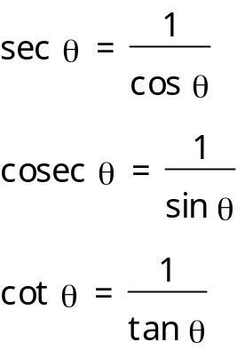

You also need to know that:

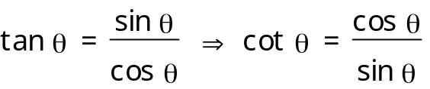

Remember to decide whether or not the ratio is +ve or –ve, either use the trig graph or the “CAST” diagram

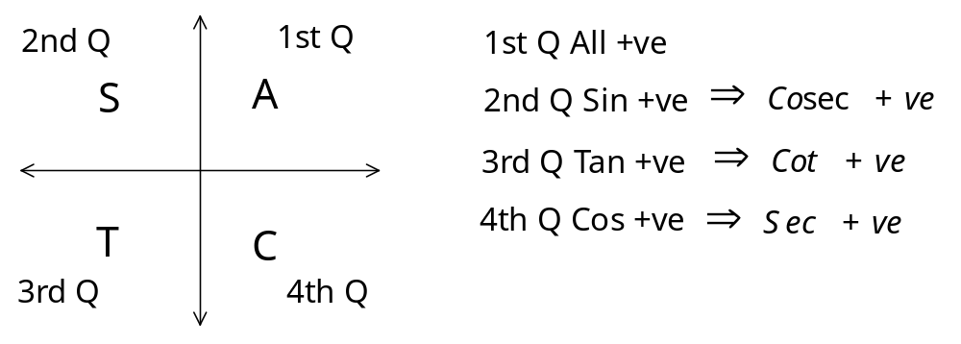
Example 1

Use your calculator to work out cosec 250º

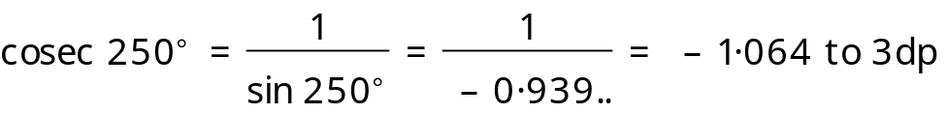

Example 2

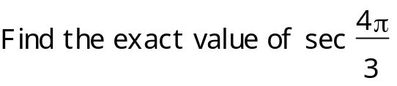
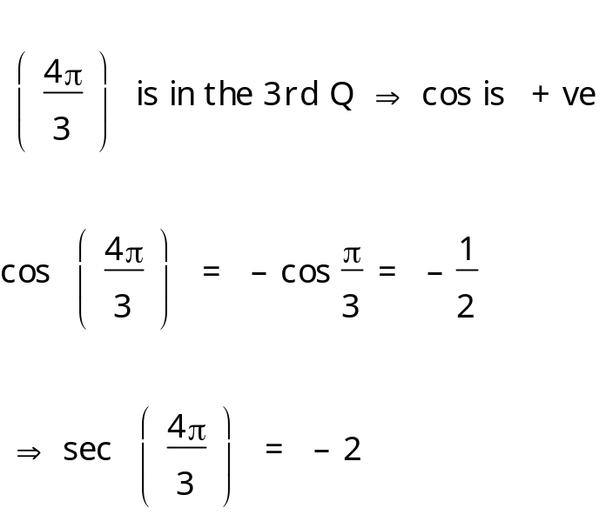

Ex 6A p 75
THE GRAPHS OF SEC θ, COSEC θ & COT θ

GRAPH OF SEC θ

1
2
3
4
5
-1
-2
-3
-4
-5
180
360
-180
-360
0
y = cosx
y = secx

This graph is symmetrical about the y-axis

It has vertical asymptotes at all values of θ for which
θ = 90º + 180nº where n is an integer

It is undefined at all these values of θ

It has a period of 360º

GRAPH OF COSEC θ
1
2
3
4
5
-1
-2
-3
-4
-5
180
360
-180
-360
0
y = sinx
y = cosecx

This graph has half-turn symmetry about O

It has vertical asymptotes at all values of θ for which
θ = 180nº where n is an integer

It is undefined at all these values of θ

It has a period of 360º

This graph could also be drawn by considering:
i.e. translate the graph of sec θ 90º to the right
GRAPH OF COT θ
1
2
3
4
5
-1
-2
-3
-4
-5
180
360
-180
-360
0
y = tanx

1
2
3
4
5
-1
-2
-3
-4
-5
180
360
-180
-360
0
y = cotx

It has vertical asymptotes at all values of θ for which
θ = 180nº where n is an integer

It is undefined at all these values of θ

It has a period of 180º

Example

Sketch the graph of y = sec 2x + 3 for 0º ≤ x ≤ 360º

First use the graph of sec x and use it to draw the graph of sec 2x by compressing it with a factor of 2
2
-2
90
180
270
360
0
x
y

Now translate it 3 units up
2
4
90
180
270
360
0
x
y

Ex 6B p 78
SIMPLIFYING EXPRESSIONS
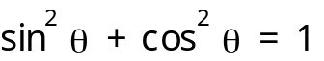
Remember that

Example

Simplify tan θ cos θ cosec θ

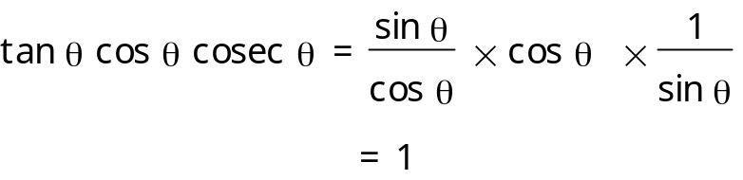

Ex 6C Q 1-3

PROVING IDENTITIES

Example

Prove that 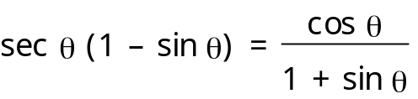

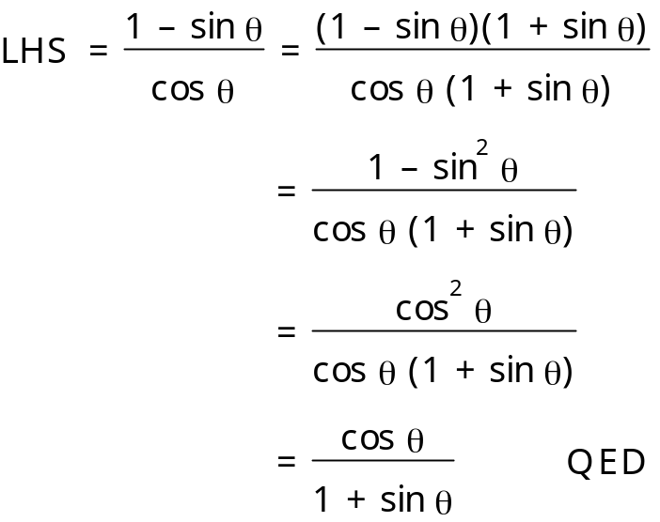

Ex 6C Q3
SOLVING EQUATIONS

Example 1

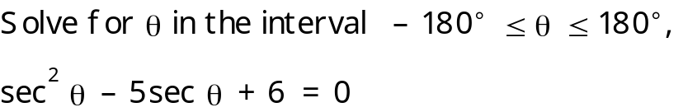

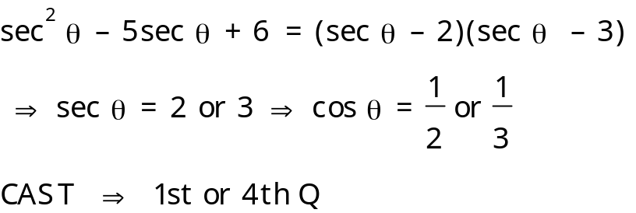

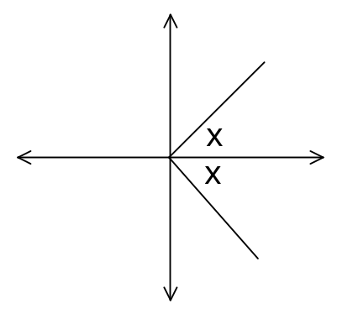

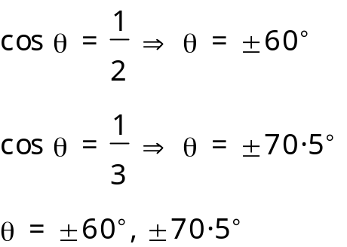
Example 2

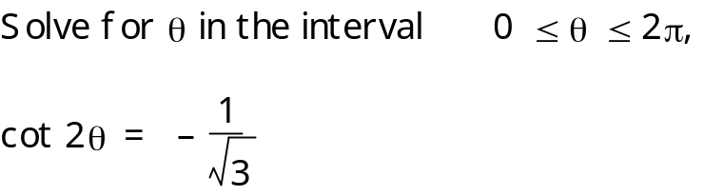

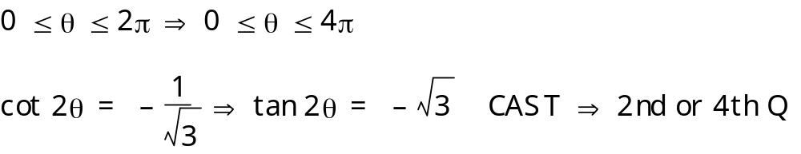
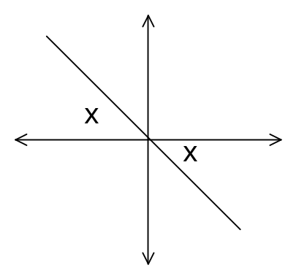

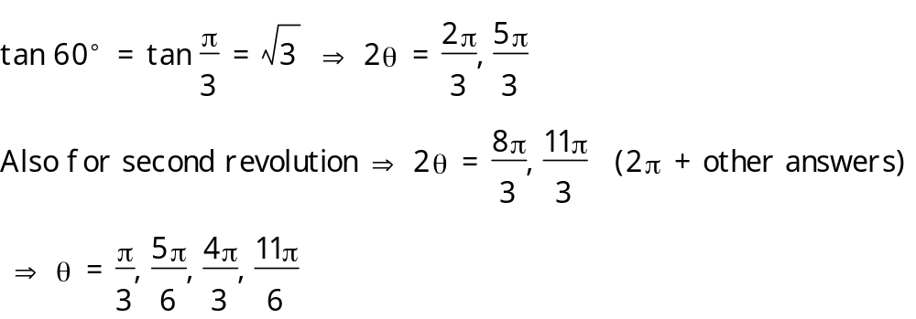
Ex 6C Q 5-8
OTHER TRIGONOMETRIC IDENTITIES

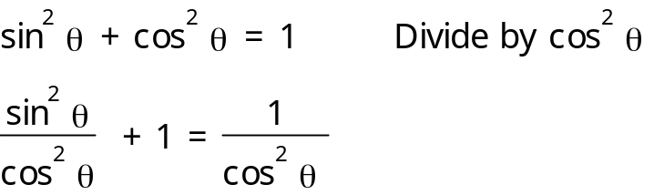
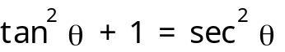

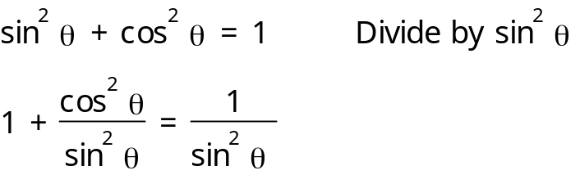
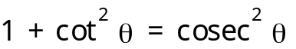

Example 1

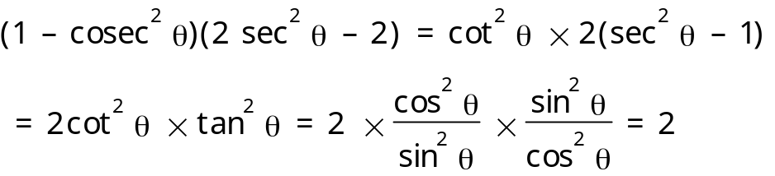

Example 2

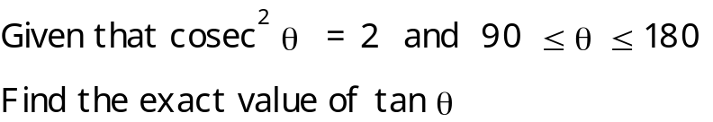

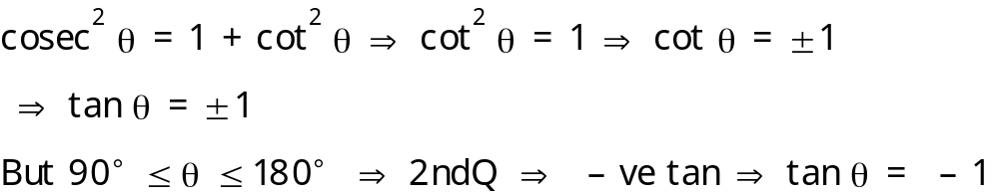

Ex 6D Q 1-7
Example 3

Solve the equation

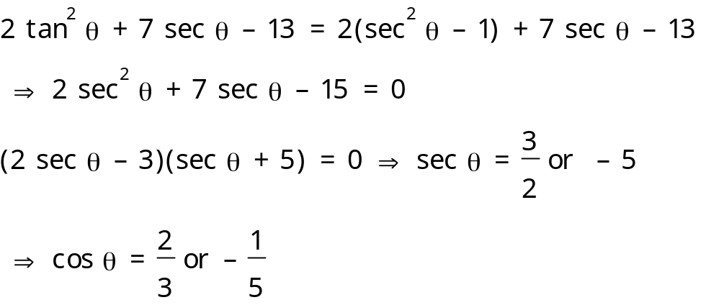
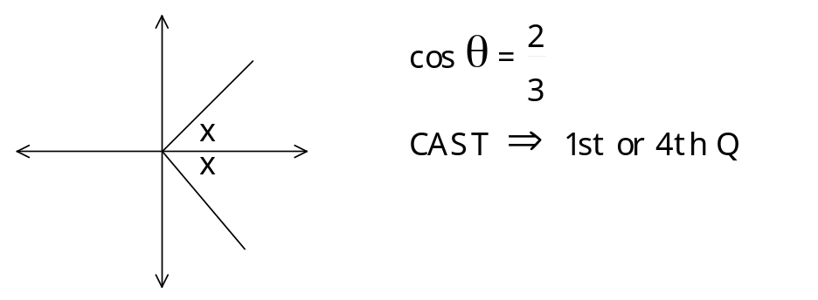

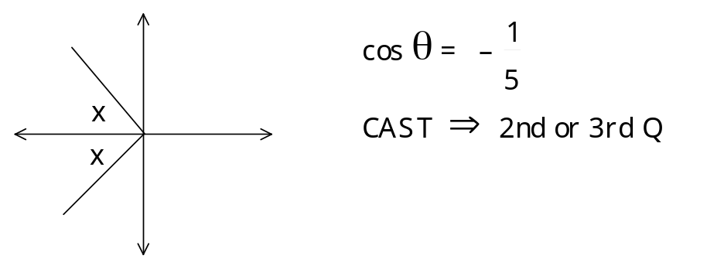

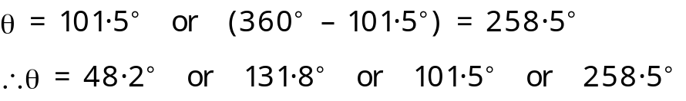

Ex 6D Q8-12 p 86
INVERSE TRIGONOMETRIC FUNCTIONS

One-to-one functions have inverse functions which can be found by reflecting the graph of the function in the line y = x

The trig functions sin x, cos x & tan x only have inverses if we restrict their domains so that they are one-to-one functions

The inverse function of sin x is arcsin x (or sin⁻¹ x)
It represents the angle whose sine is x in the interval
-90º to 90º

The graph of y = sin x with a restricted domain:
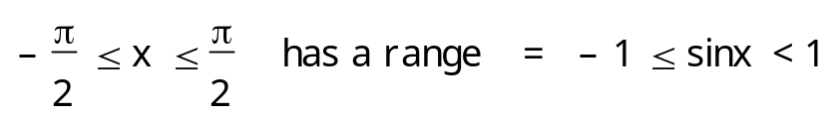
2
-2
45
90
-45
-90
0
x
y

This is reflected in the line y = x
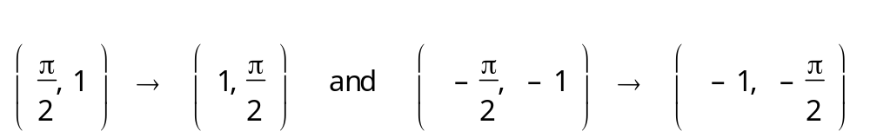
45
90
-45
-90
0.5
1
-0.5
-1
0
x
y
Y = arcsin x

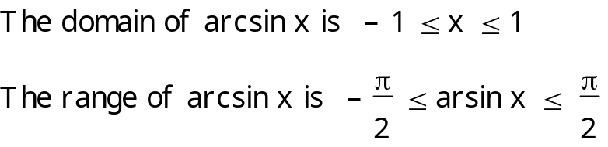

Similarly for y = arccos x (or cos⁻¹ x)
The graph of y = cos x with a restricted domain
2
-2
45
90
135
180
0
x
y

This is reflected in the line y = x 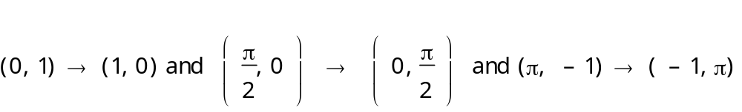
45
90
135
180
0.5
1
-0.5
-1
0
x
y
y = arcos x

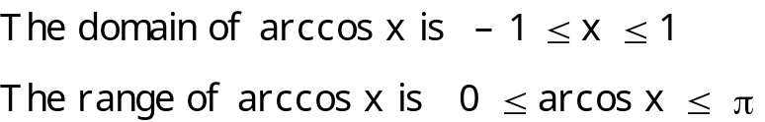

Similarly for y = arctan x (or tan⁻¹ x)
The graph of y = tan x with a restricted domain
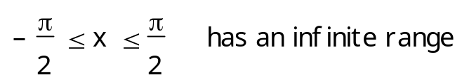
2
-2
45
90
-45
-90
0
x
y

This is reflected in the line y = x
45
90
-45
-90
2
4
-2
-4
0
x
y
y = arctan x

The domain of arctan x is x ε R
The range of arctan x is -90º ≤ arctan x ≤ 90º

Ex 6E p 90
Mixed Ex 6F p 91

